EX NO:06
DATE:
HALLOWEEN EVENT PLANNING DASHBOARD
AIM: This Dashboard explains the evaluation of the individuals who participate in Halloween activities. It is used to understand the event planning. The following information we can get from this dashboard.
- Find the precipitation level
- Forecast the future event
- Show year by year variation
- Display visitor strength

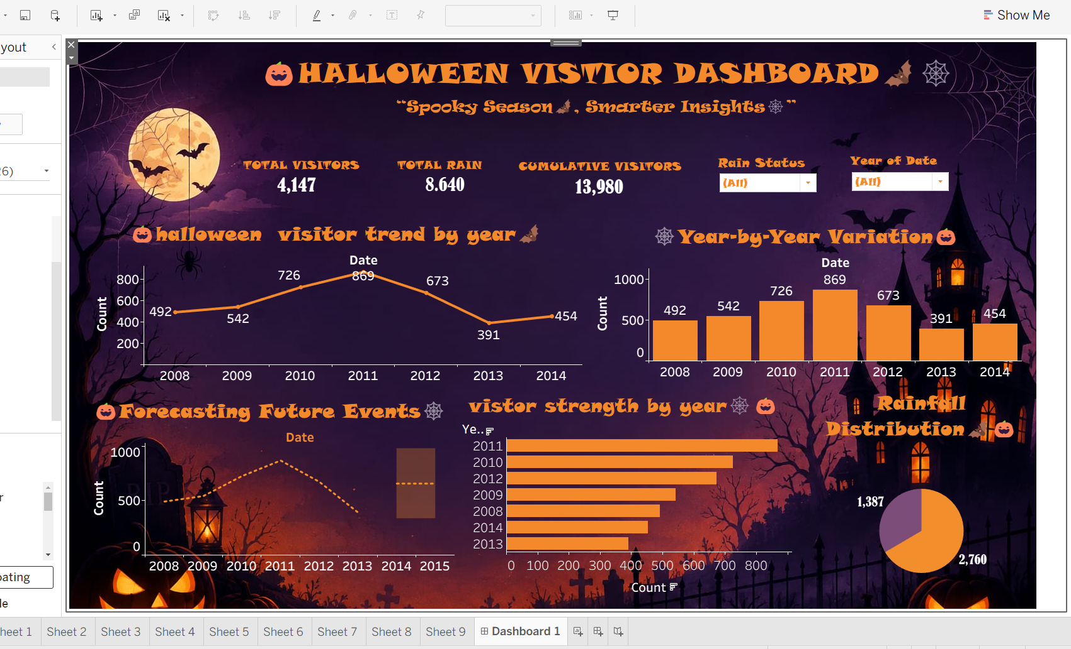

OVERALL INTERPRETATION:
The Halloween Event Planning Dashboard helps organizers analyze weather conditions, forecast future trends, compare yearly variations, and understand visitor participation. These insights support better scheduling, resource allocation, and overall event planning.
These are the charts used in dashboard.

